HAF - Information for parents and carers
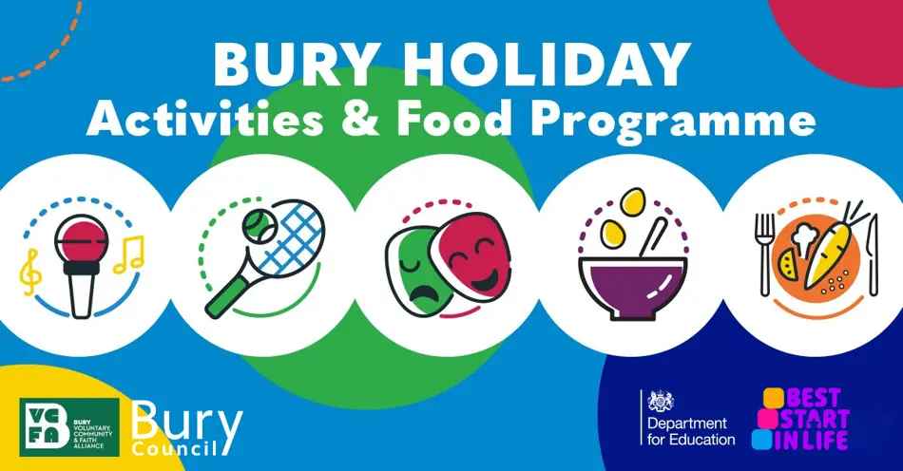
About the programme
The Holiday Activities and Food (HAF) programme is funded by the Department for Education. It funds holiday activities with food for eligible children during the Spring, Summer and Winter school holidays.
We are working with local schools, childcare and holiday club providers and voluntary and community organisations to deliver the programme across Bury. You can find out more about the programme on Gov.uk - Holiday activities and food programme.
Bury Holiday Activities and Food (HAF) programme activities are brought to you through Bury Council, in partnership with Bury Voluntary, Community and Faith Alliance and they are funded by Government (Department of Education).
Eligibility
To be eligible for a free place, children must be of primary or secondary school age and receive benefits related free school meals.
Eligible children will be able to access:
- Up to 16, four hour sessions throughout the Summer holidays
- Up to 4, four hour sessions through the Spring and Winter holidays
There will be no cost to parents for the sessions.
If you believe you are eligible for benefits related free school meals, but do not currently claim them, you can find information about how to apply on our free school meals web page.
The Local Authority has the discretion to offer a limited number of free or subsidised holiday club places to children who are not in receipt of benefits-related free school meals but who the LA believe could benefit from HAF provision. These children must be referred to us by a school or professional working with the family.
What's provided
Providers will host a variety of free fun activities, including sports, music, arts and other exciting opportunities to learn and develop skills.
Children will also receive a nutritious meal each day.
SEND children and the four suitability support levels
Our providers offer activities to children of different needs and abilities and some provide specific sessions for children with Special Educational Needs and Disabilities (SEND) or additional needs.
About the four suitability support levels
Open All
Level 1 (mild needs)
Level 2 (moderate needs)
Level 3 (risky behaviours)
Level 4 (moderate to severe needs)
How to find holiday activities
Find HAF funded providers, their activities, and how to book on the HAF Activities page.
HAF activities will also be listed on the Bury Directory booking system and information about how to book will be sent to eligible families.
Please do not contact providers directly to book on, bookings need to be made through Holiday Activities.
Children attending schools outside the Borough of Bury
If your child attends a school outside of the borough, please email haf@bury.gov.uk for support in receiving your voucher.
Contact us
If you need further information on the HAF programme or any of the clubs and activities, please email: haf@bury.gov.uk.
Follow us on Facebook: Bury Holiday Activities and Food Programme
Non-HAF support during February, May and October half term holidays
The HAF programme is not funded to provide holiday clubs over the half term holidays, but other activities and support may be available to families. You can visit The Bury Directory to find out what is available in your area. Please note that these are not HAF funded programmes so we cannot guarantee availability.
Families who are eligible for Universal Credit may be able to claim back up to 85% of their childcare costs. You can find information about help with childcare costs on Gov.uk - Universal Credit and childcare.
Share:
Share page
Share page to FacebookShare page to Twitter
Related Pages
- Holiday Activities and Food programme

