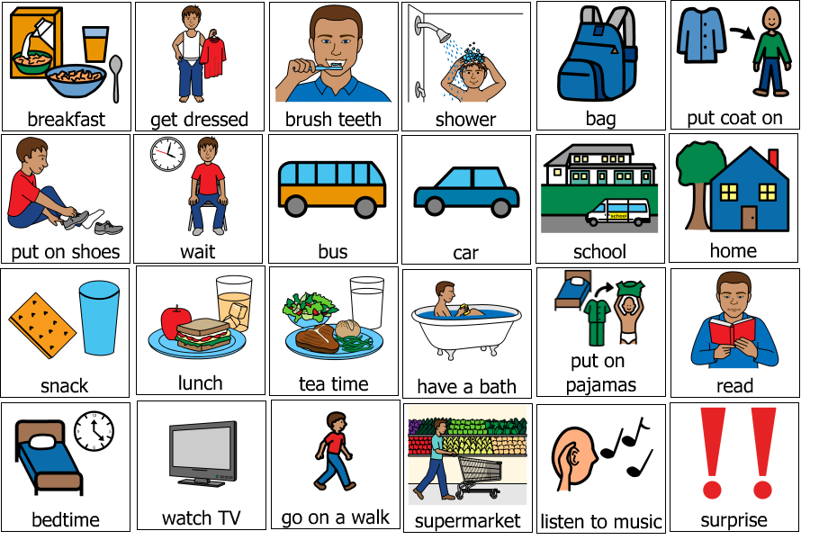

**What to do: Cut out and laminate symbols**

**How to use: Use on a timeline strip to explain the order of what is happening**